Independent Course work I – WS 2019/2020

Master Software Engineering for Industrial Applications

University of Applied Science Hof

NutriSpec Project

Project Guide: Mr. Oliver Hader

Participants

|  |  |
| --- | --- |
| Kunal Harkare | 00512519 |
| Nikhil Gosavi | 00608419 |
| Sudarshan Phule | 00510519 |
| Sachin Tiptur | 00518719 |
| Akhil Baby | 00571419 |

Table of Contents

Planning 3

Concept 3

Structure & Navigation 3

Layout and Wireframes 4

Use Cases 9

Domain Model/ER Diagram/Class diagram 10

Activity Diagrams 11

Activity diagrams of enrol and disenroll client 12

Project Organization 13

Implementation 13

Site Package 13

Page Design 13

Menu Structure 14

Core Functionality 14

Record Storage Folders 14

Roles 15

Extbase Application 15

Domain Model 15

Plugin & Controller Orchestration 16

HomePage Plugin 16

Nutritionweb 16

Client list 16

Deployment Strategy 16

Quality Assurance 17

Manual Test Cases 17

Automated Test Cases 18

Conclusion 18

Pros 18

Cons 18

# Planning

## Concept

Our application ‘NutriSpec’ aimed at every individual to search, consult nutritionist and maintain their Nutrition plan. This also connects client with Nutritionists based on the location of the client, Nutritionists to manage their clients’ data and consult online. It enables nutritionists to provide their service online by interacting with clients over this application.

Nutritionists can enrol with the ‘NutriSpec’ company administrator and make their profile visible/reachable to millions of clients. They can also get a personalized Nutritionist page with details of their clients and related data. Nutritionist can update the client information with the consultation reports and diet prescriptions. Also, he can monitor the progress of the client. A nutritionist can also write blogs and success stories in the application.

Client can search for a Nutritionist without requiring a registration. A location-based search is possible with ‘NutriSpec.’ Client can get contact details of the Nutritionist and view the Nutritionist profile, ratings, qualifications, blogs and success stories. Client can also contact Nutritionist via ‘NutriSpec’ online contact form.

Registration of each user to help monitor the individual separately and accurately. The record of user's history would be analysed to ensure better diagnosis which would be concentrated to the concerned user. User Personalization would also make users more engaged in the activities which would increase the probability of completing the tasks and thus resulting in maintaining good health. Relevant and tailored experiences also boost user retention.

# Structure & Navigation

|  |  |  |  |
| --- | --- | --- | --- |
| ID | TITLE | SCOPE | URL/PATH |
| 1 | Home Page | Login links to Nutritionist and Client home pages and also shows images in carousel | /overview |
| 2 | Client Home | List all nutritionist, search nutritionist, view blogs | /client-home |
| 2.1 | My reports | Display prescriptions from nutritionist | /client-home/reports |
| 3 | Nutritionist Home | List all enrolled client details, prescribe client, disenroll client, view blogs | /nutritionist-home |
| 4 | About Us | Information about NutriSpec | /about-us |
| 5 | Contact Us | Contact form (name, email, subject, message) | /contact-us |
| 6 | News | Recent News and announcements | /news |
| 6.1 | Vlog | Health and nutritional videos | /news/vlog |
| 7 | Legal Information | Legal information, address information, privacy policy. | /legal-information |

Table 1: Page Structure and content map of NutriSpec Application

# Layout and Wireframes

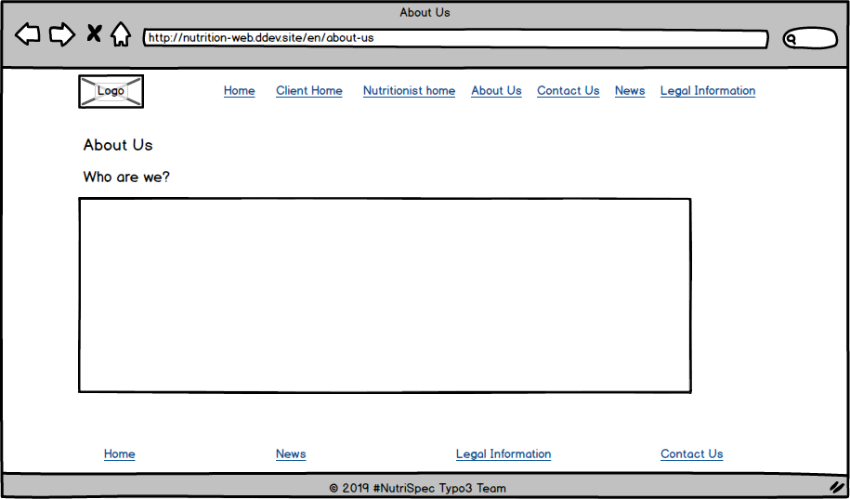

Figure 1. About Us page of NutriSpec

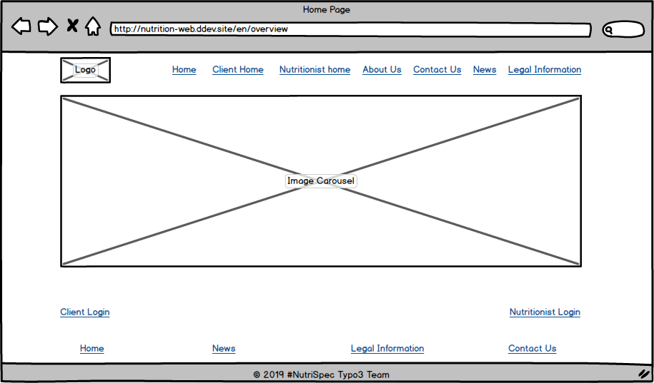

Figure 2. Home page layout showing logo and carousel

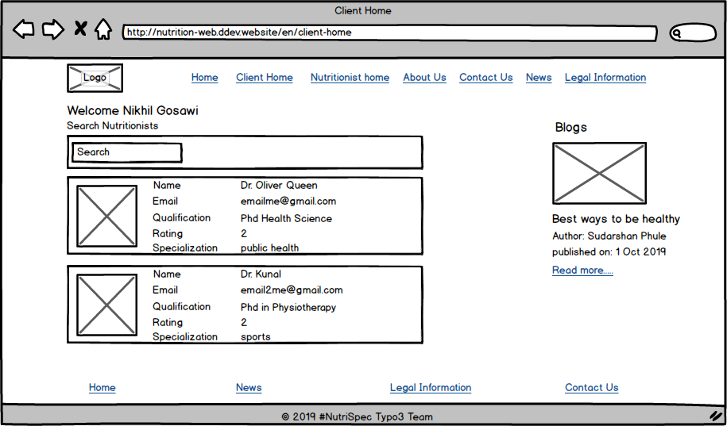

Figure 3. Client page of NutriSpec

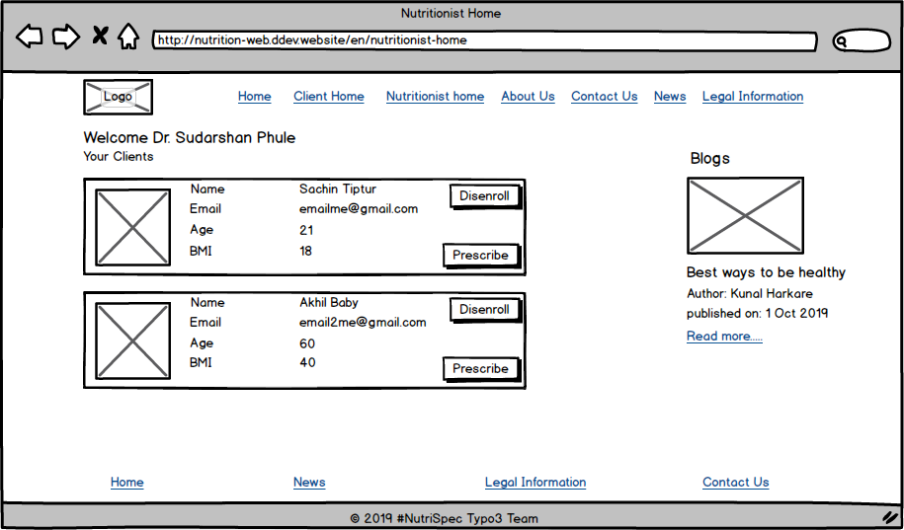

Figure 4. Nutritionist page showing list of clients

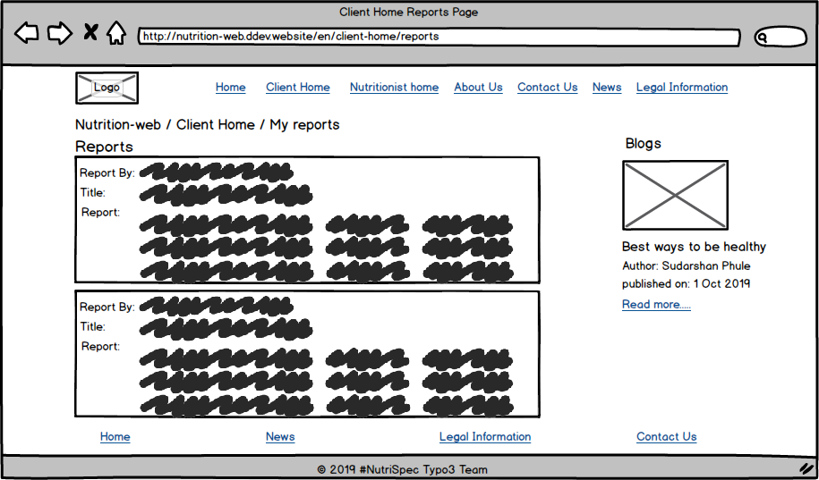

Figure 5. Client’s Report page

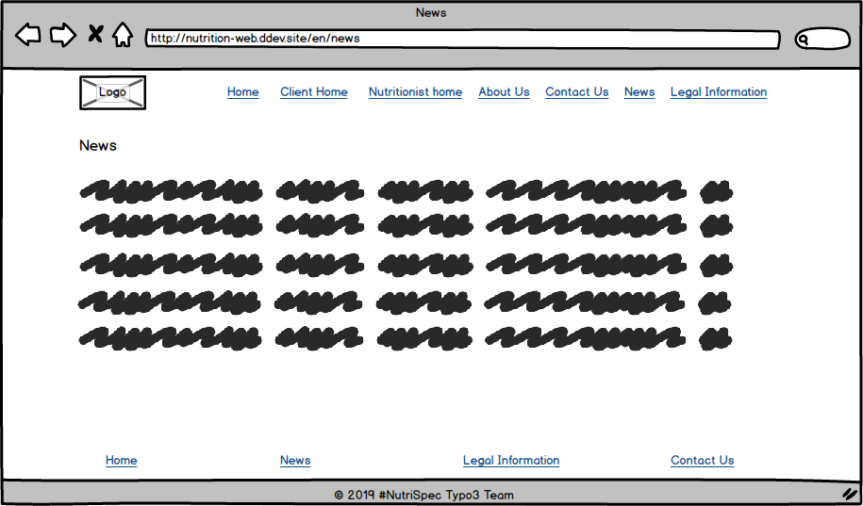

Figure 6. New page

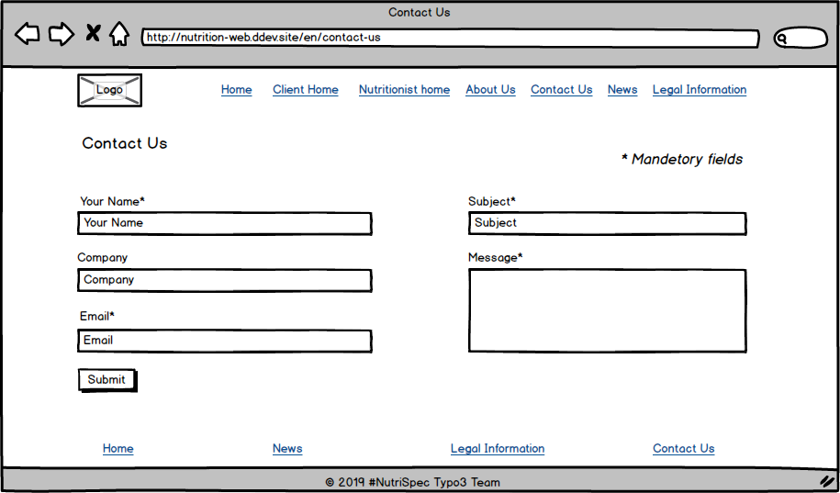

Figure 7. Contact Us page

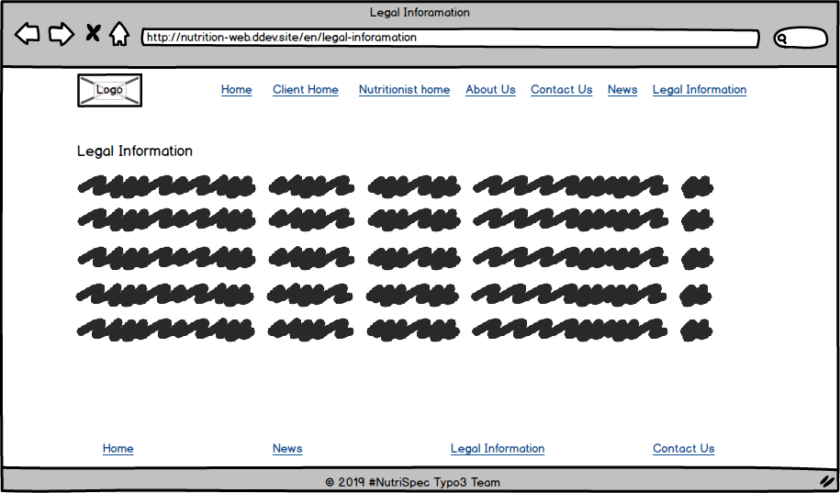

Figure 8. Legal information page

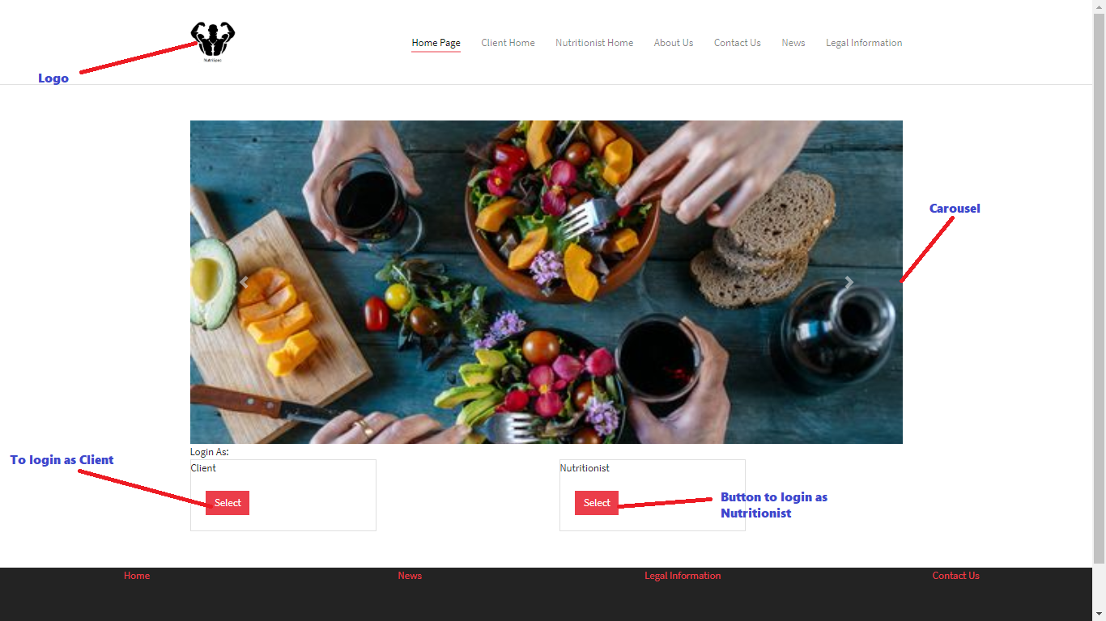

Figure 9. Home Page layout

# Use Cases

There are basically two types of users who can use this application. First one is nutritionist who can list his all clients, view client’s information, prescribe client and can create blogs.

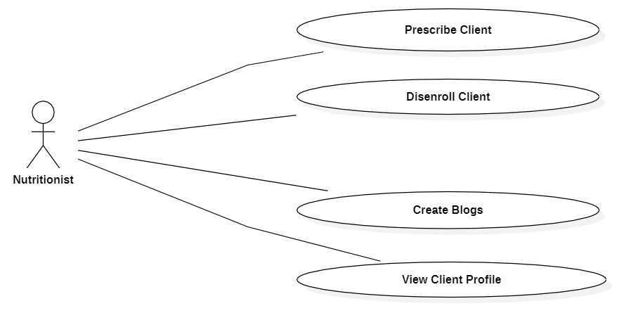

Nutritionist Role Use Case

Second actor is client who can search for nutritionist, view nutritionist profile, enrol with nutritionist, view blogs and give ratings to nutritionist.

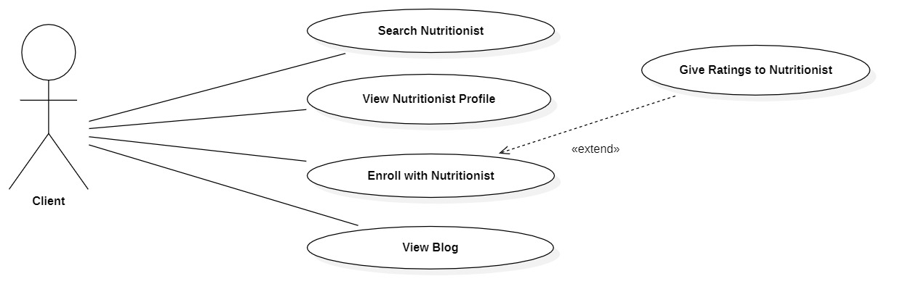

Client Role Use Case

# Domain Model/ER Diagram/Class diagram

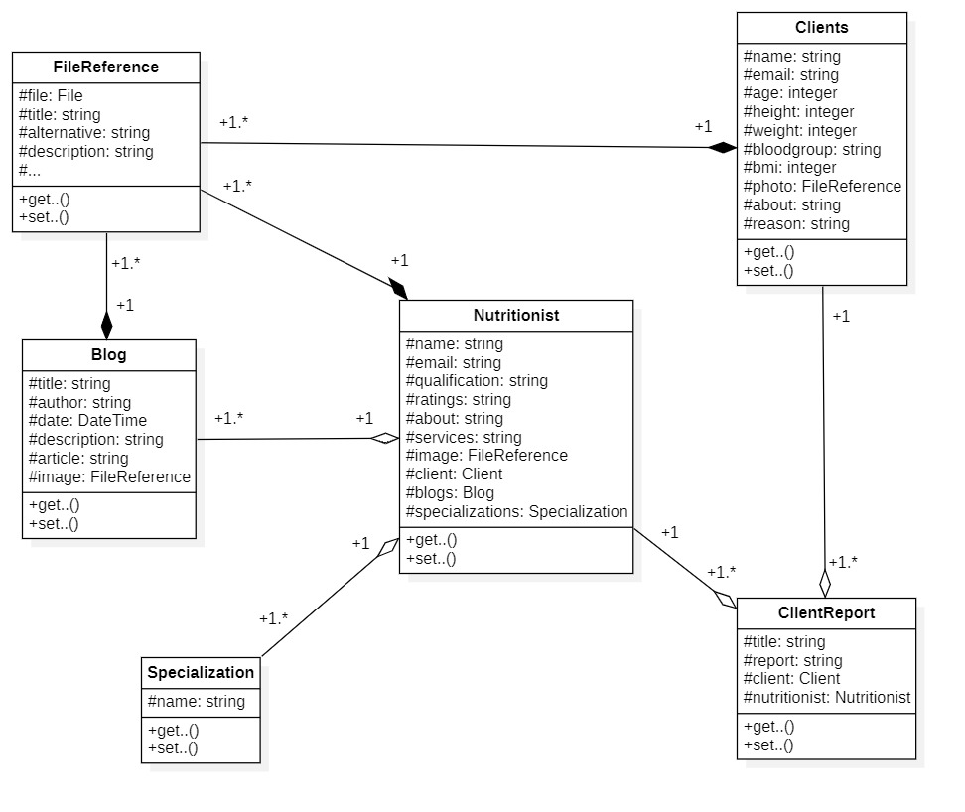

Class Diagram

# Activity Diagrams

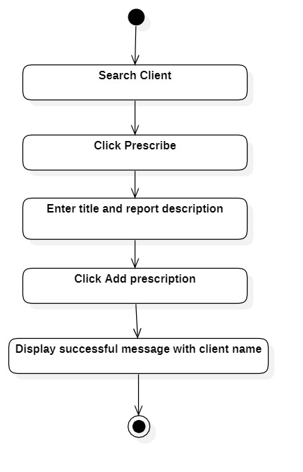

Prescribe client activity diagram

## Activity diagrams of enrol and disenroll client

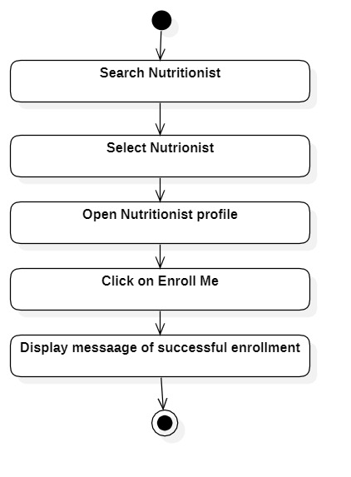

Enrol with nutritionist activity diagram

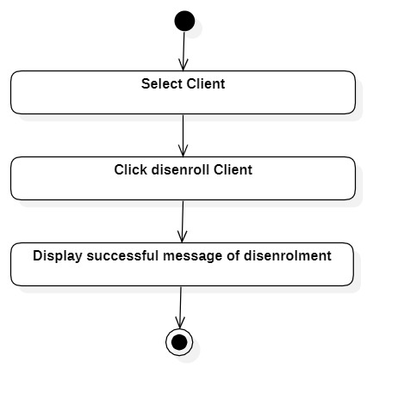

Disenroll with Client activity diagram

# Project Organization

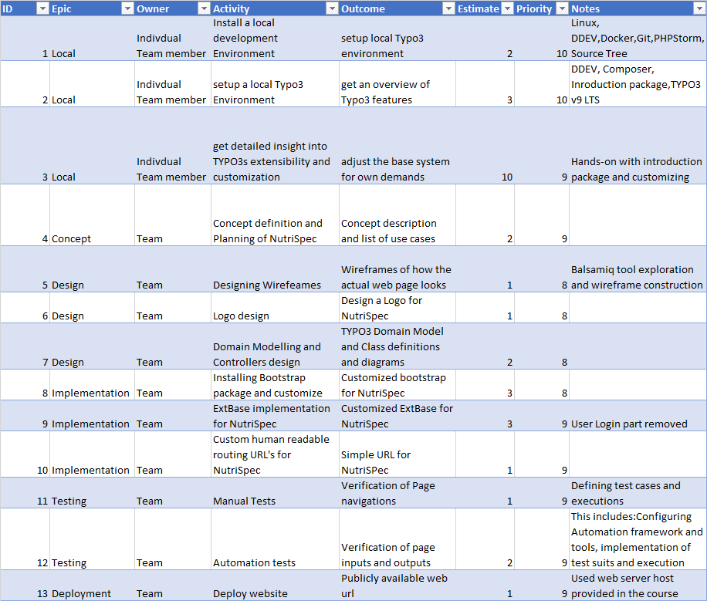

# Implementation

Source Code: <https://github.com/nikhilgosavi007/nutrition-web>

## Site Package

This section describes the changes done in Site package for NutriSpec.

### Page Design

All pages are implemented using default bootstrap shipped with TYPO3

#### Root Page

Default bootstrap page with 3 column page layout

#### Home page, Client home, Nutritionist Home

Default bootstrap page with 2 column page layout using bootstrap card style for displaying list of nutritionist and client

#### Contact Us

Default bootstrap page with form content element for submitting messages

#### Vlog

Default bootstrap page with external media as content element

#### News, About Us, Legal Information

Default bootstrap pages with Text and images as content elements

### Menu Structure

|  |  |
| --- | --- |
| ROOT | https://707namkp-xw6adrv.project.anyhost.it/en/ |
| Home Page | https://707namkp-xw6adrv.project.anyhost.it/en/overview |
| Client Home | https://707namkp-xw6adrv.project.anyhost.it/en/client-home |
| My Reports | https://707namkp-xw6adrv.project.anyhost.it/en/client-home/reports |
| Nutritionist Home | https://707namkp-xw6adrv.project.anyhost.it/en/nutritionist-home |
| About US | https://707namkp-xw6adrv.project.anyhost.it/en/about-us |
| Contact Us | https://707namkp-xw6adrv.project.anyhost.it/en/contact-us |
| News | https://707namkp-xw6adrv.project.anyhost.it/en/news |
| Vlog | https://707namkp-xw6adrv.project.anyhost.it/en/news/vlog |
| Legal Information | https://707namkp-xw6adrv.project.anyhost.it/en/legal-information |

## Core Functionality

### Record Storage Folders

#### Nutritionist Data

Contains database records that represent models in application. Following are the models that are represented as records in database:

* Blog - Model entity that represent blogs written by nutritionists
* Client Report - Model entity that represent prescription reports generated by nutritionists
* Clients - Model entity that represent all clients
* Nutritionist - Model entity that represent nutritionists
* Specialization - Model entity that represent specialization field of nutritionists

#### fileadmin/user_upload

Contains images used throughout the system for site images

### Roles

NutriSpec contains following roles:

* Client Role - Clients of the NutriSpec application who can avail nutrition related suggestions from nutritionists by enrolling with them.
* Nutritionist Role - Nutritionists registered with NutriSpec application who can suggest diets and activities to clients.

## Extbase Application

### Domain Model



NutriSpec contains nutritionists and clients as main actors. A Nutritionist has attributes like name, email, specializations etc which can be seen by Clients before enrolling with the nutritionist. Nutritionist can write nutrition related blogs. Client Report holds an association between Client and Nutritionists which associates client with nutritionist based on reports assigned by nutritionist to clients. Nutritionist also has Clients which are added to Nutritionist after enrolment. All domains containing images has a FileReference to the respective images.

## Plugin & Controller Orchestration

### HomePage Plugin

This plugin is used to display home page of NutriSpec Application which contains login for nutritionist and Client.

### Nutritionweb

This plugin is used on Client Home Page. It is used for the following:

* display nutritionist details to client
* enroll with Nutritionist
* view prescriptions assigned by Nutritionist
* view blogs written by Nutritionists

### Client list

This plugin is used on Nutritionist Home Page. It is used for the following:

* display Client details to Nutritionist
* Unroll with Nutritionist
* assign prescription to Nutritionist

## Deployment Strategy

Project deployment is done via deployer. Used below credentials and authentication method to deploy.

**Authentication method:** public key

**Login credentials:** username and hostname received from [indie.one@hosts.h4ck3r31.net](mailto:indie.one@hosts.h4ck3r31.net)

**Password:** received from [indie.one@hosts.h4ck3r31.net](mailto:indie.one@hosts.h4ck3r31.net)

**Procedure:**

1.Load public key to host by using following command

ssh-copy-id -i ~/.ssh/id__rsa.pub <username@hostname>

2. Log in to the server

ssh <username@hostname>

3. Added following lines to config file in “C:\Users\Sudarshan\.ssh”

Host <hostname>

User <username>

IdentityFile ~/.ssh/id_rsa

4. Upload local NutriSpec application to remote server using deployer toolkit

ddev composer require --dev oliver-hader/typo3-deployer

5. From phpStorm directory location vendor/oliver-hader/typo3-developer/src/

“.host.dist.yml” & “deploy.dist.php” files are copied to root directory and renamed by refactoring as “.host.yml” and “deploy.php” respectively

6. Prepare the required files as below:

* Set project name value to “nutrispec-app” in “deply.php” file
* Exclude file “.host.yml” from git repository by adding it to gitignore file
* Insert hostname in “.host.yml” file and update username and do database settings
* update hostname in site-configuration and push deployer configuration to git
* Shared Public Key authentication with DDEV container ddev auth ssh

6. Deploy local state to remote host using public key authentication

ddev exec vendor/bin/dep deploy production

# Quality Assurance

## Manual Test Cases

Environment: Local execution on user laptop

URL: <https://707namkp-xw6adrv.project.anyhost.it/en/overview>

Results and Test Cases in detail:

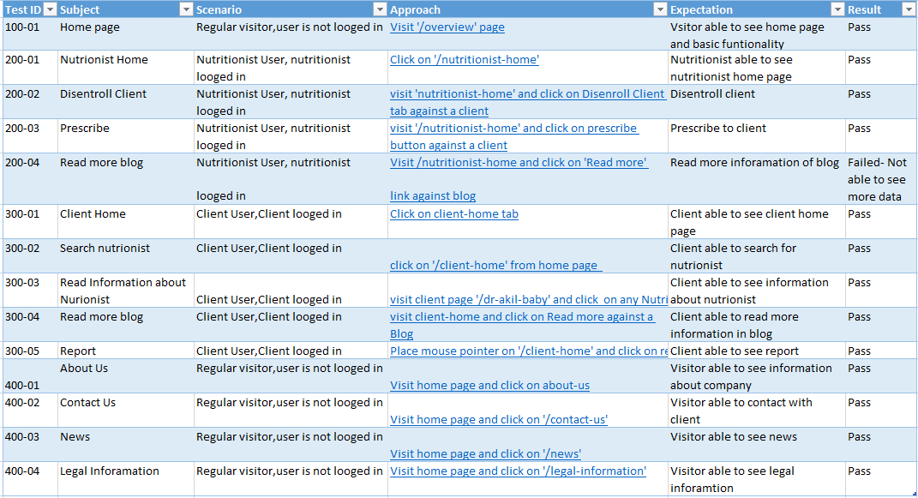

## Automated Test Cases

Webpage inputs and outputs are verified using Automated test cases. Katalon studio based on Selenium is used for implementing and testing NutriSpec test suits. Katalon Studio uses open-source test automation frameworks such as Selenium and Appium by eliminating their technical complexities. This enabled us to set up, create, run and report automated tests.

Automated test scripts were written and executed for below scenarios:

* + Enrol with Nutritionist
  + Add Prescription to Client
  + Unroll with Client

Details about automated test case is given in below repository:

https://github.com/Kharkare/NutriSpecTestCaseProject.git

# Conclusion

Overall experience in learning TYPO3 was good and enhanced our web development skills and CMS knowledge. It exposed us to different tools and environments like Docker, DDEV and Github. With the time and the limited knowledge, we were able to build a NutriSpec web site with all basic functionalities like navigating to difference pages, providing ability to contact and enrol with Nutritionists, to view vlogs and news on the site. But not able to implement some features like location-based search, chatbots and registration etc.

From our little experience, below are few pros and cons of TYPO3:

### Pros

* Long term software support for LTS versions
* Supports multi-lingual websites and managing multi-language content in an easy
* Able to manage very large and complex websites required for big business & major organisations
* Good range of free 3rd party plugins

### Cons

* Complexity is high to set up & maintain (i.e. apply bug fixes, security updates), and to add new features
* Limited 'themes' to change look & design of website without use of professional web developers
* No automatic updates for the CMS